Decagonal Rotunda
# Source: AI Source: Provided by: [Data Path: Persons Table -> ID Column: 1, Name_En Column: Motasem Essam] -> From: [ChatGPT] on [7/25/2026]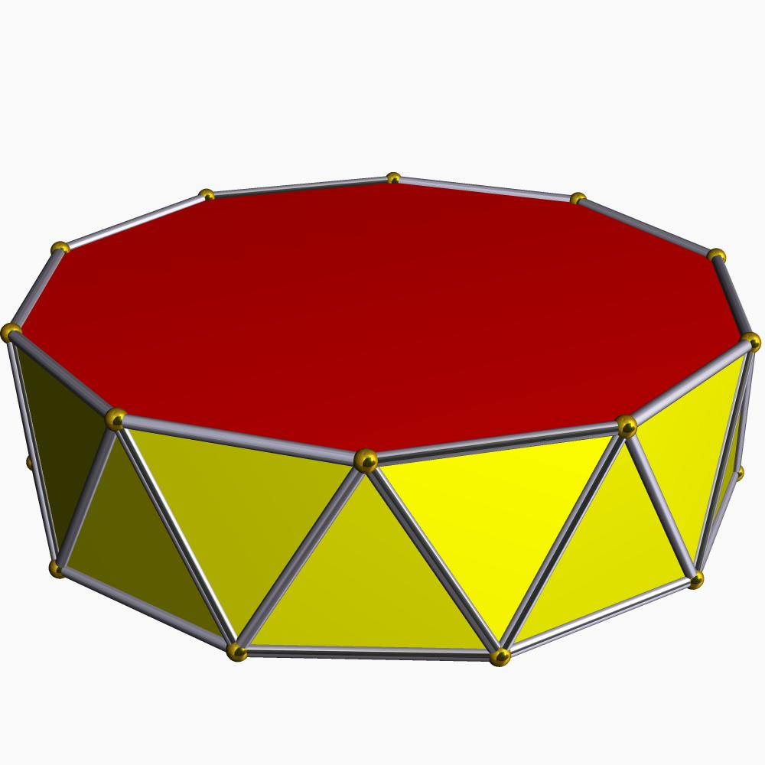

Definition
# Source: AI Source: Provided by: [Data Path: Persons Table -> ID Column: 1, Name_En Column: Motasem Essam] -> From: [ChatGPT] on [7/25/2026]
A Decagonal Rotunda is a generalized rotunda-type polyhedron constructed with a decagonal (10-sided) upper base and a parallel icosagonal (20-sided) lower base.
Its lateral surface consists of alternating triangular and pentagonal faces arranged around the solid.
- 1 decagonal upper base.
- 1 icosagonal lower base.
- 20 triangular lateral faces.
- 10 pentagonal lateral faces.
The Decagonal Rotunda follows the generalized rotunda construction. It is not one of the classical Johnson solids; the Pentagonal Rotunda is the classical regular-faced rotunda.

Geometric Structure
# Source: AI Source: Provided by: [Data Path: Persons Table -> ID Column: 1, Name_En Column: Motasem Essam] -> From: [ChatGPT] on [7/25/2026]
The structure is based on two parallel polygonal bases:
- Upper Base: A decagon with 10 sides.
- Lower Base: An icosagon with 20 sides, positioned parallel to the upper base and rotated relative to it.
- Lateral Surface: A band of 30 faces consisting of 20 triangles and 10 pentagons.
The triangular and pentagonal faces alternate around the lateral structure.

Face Composition
# Source: AI Source: Provided by: [Data Path: Persons Table -> ID Column: 1, Name_En Column: Motasem Essam] -> From: [ChatGPT] on [7/25/2026]
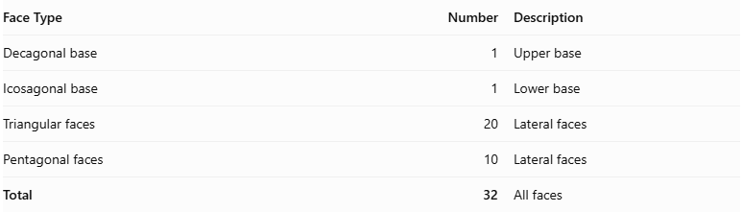
Face Type | Number | Description
Decagonal base | 1 | Upper base
Icosagonal base | 1 | Lower base
Triangular faces | 20 | Lateral faces
Pentagonal faces | 10 | Lateral faces
Total | 32 | All faces

Mathematical Properties
# Source: AI Source: Provided by: [Data Path: Persons Table -> ID Column: 1, Name_En Column: Motasem Essam] -> From: [ChatGPT] on [7/25/2026]
For a generalized rotunda with $n=10$:
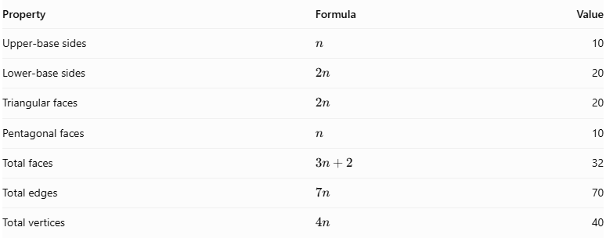
Property | Formula | Value
Upper-base sides | $$n$$ | 10
Lower-base sides | $$2n$$ | 20
Triangular faces | $$2n$$ | 20
Pentagonal faces | $$n$$ | 10
Total faces | $$3n+2$$ | 32
Total edges | $$7n$$ | 70
Total vertices | $$4n$$ | 40
Euler's Polyhedron Formula:
$$V-E+F=2$$
Substituting the values:
$$40-70+32=2$$
Therefore, the mathematical counts satisfy Euler's formula for a topologically spherical polyhedron.

Geometric Characteristics
# Source: AI Source: Provided by: [Data Path: Persons Table -> ID Column: 1, Name_En Column: Motasem Essam] -> From: [ChatGPT] on [7/25/2026]
- Upper Base Shape: Decagon.
- Lower Base Shape: Icosagon.
- Lateral Face Types: Triangles and pentagons.
- Total Faces: 32.
- Total Edges: 70.
- Total Vertices: 40.
- Rotational Symmetry: Tenfold rotational symmetry in the symmetric arrangement.
- Convexity and Regularity: These depend on the particular geometric realization. The generalized construction does not require every face to be regular or all edges to have equal lengths.

Construction of Decagonal Rotunda

Geometric Instruments Used
# Source: AI Source: Provided by: [Data Path: Persons Table -> ID Column: 1, Name_En Column: Motasem Essam] -> From: [ChatGPT] on [7/25/2026]
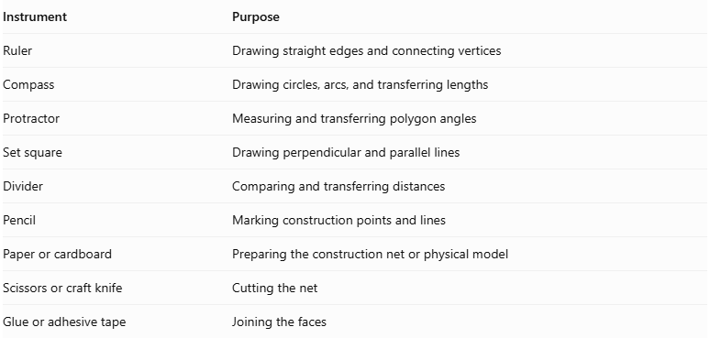
Instrument | Purpose
Ruler | Drawing straight edges and connecting vertices
Compass | Drawing circles, arcs, and transferring lengths
Protractor | Measuring and transferring polygon angles
Set square | Drawing perpendicular and parallel lines
Divider | Comparing and transferring distances
Pencil | Marking construction points and lines
Paper or cardboard | Preparing the construction net or physical model
Scissors or craft knife | Cutting the net
Glue or adhesive tape | Joining the faces

Instrument-Based Construction Procedures
# Source: AI Source: Provided by: [Data Path: Persons Table -> ID Column: 1, Name_En Column: Motasem Essam] -> From: [ChatGPT] on [7/25/2026]
No coordinate-based construction
The construction uses geometric instruments, measured lengths, angles, polygon geometry, and face-to-face edge matching. It does not use coordinate axes, coordinate points, or coordinate equations.
Constructibility note: Regular decagons and regular icosagons can both be constructed exactly using a compass and straightedge.

A. Construct the Upper Regular Decagonal Base
# Source: AI Source: Provided by: [Data Path: Persons Table -> ID Column: 1, Name_En Column: Motasem Essam] -> From: [ChatGPT] on [7/25/2026]
- Draw a circle using a compass.
- Mark its center.
- Construct a regular decagon inscribed in the circle.
- Divide the circumference into ten equal central angles.
- Each central angle measures:
$$\frac{{360}^{°}}{10}={36}^{°}$$
- Mark the ten points on the circumference.
- Join consecutive points using a ruler.
- Verify that the ten sides are equal.
- Label the vertices.

B. Construct the Lower Regular Icosagonal Base
# Source: AI Source: Provided by: [Data Path: Persons Table -> ID Column: 1, Name_En Column: Motasem Essam] -> From: [ChatGPT] on [7/25/2026]
- Draw a second circle using a compass.
- Mark its center.
- Divide the circumference into twenty equal central angles.
- Each central angle measures:
$$\frac{{360}^{°}}{20}={18}^{°}$$
- Mark the twenty points on the circumference.
- Join consecutive points using a ruler.
- Verify that the twenty sides are equal.
- Label the vertices.

C. Construct the Twenty Triangular Lateral Faces
# Source: AI Source: Provided by: [Data Path: Persons Table -> ID Column: 1, Name_En Column: Motasem Essam] -> From: [ChatGPT] on [7/25/2026]
- Prepare twenty triangular faces using a ruler, compass, and protractor.
- Determine their side lengths and angles from the selected Decagonal Rotunda model.
- Arrange the triangles according to the intended lateral face pattern.
- Match their edges to the appropriate edges of the pentagonal faces and bases.
- Verify that each triangle fits its neighboring faces without gaps or unintended overlaps.

D. Construct the Ten Pentagonal Lateral Faces
# Source: AI Source: Provided by: [Data Path: Persons Table -> ID Column: 1, Name_En Column: Motasem Essam] -> From: [ChatGPT] on [7/25/2026]
- Prepare ten pentagonal faces.
- Determine their side lengths and interior angles from the selected model.
- Arrange the pentagons alternately within the lateral face arrangement.
- Match their edges with the appropriate neighboring triangular faces.
- Verify that the ten pentagons complete the lateral structure correctly.

E. Arrange the Faces
# Source: AI Source: Provided by: [Data Path: Persons Table -> ID Column: 1, Name_En Column: Motasem Essam] -> From: [ChatGPT] on [7/25/2026]
- Position the regular decagonal upper base and regular icosagonal lower base parallel to each other.
- Arrange the twenty triangles and ten pentagons between the two bases.
- Check the lengths of all shared edges.
- Verify the intended tenfold rotational arrangement.
- Confirm that every edge belongs to exactly two faces and that the surface closes without gaps or overlaps.

F. Assemble the Solid
# Source: AI Source: Provided by: [Data Path: Persons Table -> ID Column: 1, Name_En Column: Motasem Essam] -> From: [ChatGPT] on [7/25/2026]
- Prepare a verified construction net or separate face pieces with the correct adjacency arrangement.
- Add joining tabs if using paper or cardboard.
- Cut out the faces.
- Fold the required edges if using a net.
- Join the matching lateral faces.
- Attach the upper decagonal base and lower icosagonal base.
- Inspect the completed model from several directions.
Construction accuracy: The ten pentagons and twenty triangles must have dimensions and angles compatible with the selected generalized model. Simply using regular pentagons, equilateral triangles, a regular decagon, and a regular icosagon does not guarantee a valid closed Decagonal Rotunda. The face geometry and adjacency must be verified before assembly.

Key Points
# Source: AI Source: Provided by: [Data Path: Persons Table -> ID Column: 1, Name_En Column: Motasem Essam] -> From: [ChatGPT] on [7/25/2026]
- The Decagonal Rotunda has a 10-sided upper base and a 20-sided lower base.
- Its lateral surface contains 20 triangles and 10 pentagons.
- It has 32 faces, 70 edges, and 40 vertices.
- It has tenfold rotational symmetry.
- It is a generalized rotunda, not a classical Johnson solid.
- Its construction follows the general rotunda arrangement of triangular and pentagonal lateral faces.

Main Classification
# Source: AI Source: Provided by: [Data Path: Persons Table -> ID Column: 1, Name_En Column: Motasem Essam] -> From: [ChatGPT] on [7/25/2026]
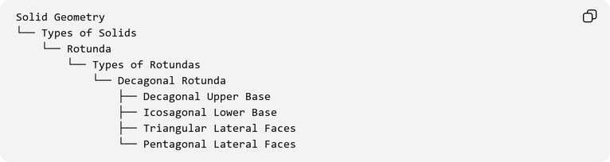
Solid Geometry
└── Types of Solids
└── Rotunda
└── Types of Rotundas
└── Decagonal Rotunda
├── Decagonal Upper Base
├── Icosagonal Lower Base
├── Triangular Lateral Faces
└── Pentagonal Lateral Faces

Conclusion
# Source: AI Source: Provided by: [Data Path: Persons Table -> ID Column: 1, Name_En Column: Motasem Essam] -> From: [ChatGPT] on [7/25/2026]
The Decagonal Rotunda is a generalized rotunda-type polyhedron with a decagonal upper base, an icosagonal lower base, and an alternating arrangement of triangular and pentagonal lateral faces. Its topological structure gives it 32 faces, 70 edges, and 40 vertices, with tenfold rotational symmetry.

